Super-Resolution of Thermal IR Imagery via Optical Guidance

Chunchu Saisree, G.A. Videesh Reddy, Kamparaju Keshasree

DR. Yamanappa (Corresponding Author)

School of Computer Science and Engineering, Presidency University, Bangalore, India

Department of Computer Science and Engineering, Bangalore

CHUNCHU.20221CAI0051@presidencyuniversity.in ,

GUNDREDDY.20221CAI0044@presidencyuniversity.in,

KAMPARAJU.20221CAI0057@presidencyuniversity.in

yamanappa@presidencyuniversity.in

Abstract - TIR imaging systems are able to obtain information about temperatures present in the image scene without the need for visible light illumination, making them applicable in a variety of applications, including surveillance and automotive safety systems, among others. Unfortunately, thermal cameras typically have lower resolution than regular RGB cameras, resulting in an absence of finer structural details in the thermal image. This study presents a novel SR solution based on deep learning applied to TIR images using corresponding RGB images as references.
A paired dataset comprising RGB and thermal images is constructed for this experiment through an elaborate preprocessing framework. First, the RGB images are transformed into grayscale images to create high-resolution thermal images, followed by bicubic downscaling to produce low-resolution thermal images. Finally, all the images are uniformly scaled to a specific resolution and normalized to the interval [0,1] for effective training.
The following SR algorithms are assessed: SRCNN, EDSR, SwinIR, as well as the novel guided SR models: DCSR, GDSR, and GASR. Guided models apply structural information from RGB images based on feature integration, edge detection through Canny operator, and adaptively weighted according to confidence to address cross-spectral differences.
In order to preserve image fidelity and thermal integrity, a compound loss is applied with pixel-wise image generation loss and radiometric integrity loss. Experiment results indicate that guided models outperform non-guided SR approaches in terms of PSNR and SSIM metrics, while retaining thermal properties. Of all the models, the GDSR model performs better regarding image reconstruction quality. Meanwhile, the GASR model exhibits better robustness under complex RGB scenarios such as noisy, foggy, or dark RGB conditions. In general, the method described above has shown that the combination of optical guidance with proper preprocessing and modeling can lead to enhanced thermal image super-resolution while maintaining radiometric accuracy.
Keywords: Thermal infrared super-resolution, optical guidance, SRCNN, EDSR, SwinIR, dual-channel fusion, gradient-guided SR, adaptive fusion, radiometric fidelity, deep learning, convolutional neural networks, cross-modal attention.
- Introduction
The thermal infrared cameras use the 8 to 14 micro meter range of long-wave infrared (LWIR) light to detect blackbody radiation which scene objects emit. The thermal sensors develop their visual representation through the thermal energy found in a scene which makes them suitable for nighttime walking detection and energy assessment of buildings and industrial equipment failure detection and medical thermography research [1]. The thermal cameras have become vital technology for automotive safety systems because they provide the ability to identify both pedestrians and animals in conditions that RGB cameras cannot function. Uncooled microbolometer detectors enable thermal focal-plane arrays (FPAs) to provide several benefits but their operational capabilities are restricted to a pixel pitch range of 12–17 μm and an array size limitation between 160×120 and 640×480 pixels. The system enables co-mounted RGB cameras to produce multi-megapixel images with less than 3 μm pitch at the same cost as their current system. The existing resolution gap between 4× and 16× creates a need for computational super-resolution (SR) which functions as a budget-friendly substitute for expensive thermal equipment [2]. Bicubic interpolation and sparse coding form the basis of traditional SR techniques which generate overly smooth results that cannot restore the high-frequency edge details. Deep learning SR techniques develop through the combination of SRCNN [3] and residual networks [4] with generative adversarial models [5] and transformer architectures [6]. The single-
image approaches lack the capability to utilize detailed structural data available in their environment. These are inferred solely from the registered high resolution RGB frame captured by the corresponding sensor.
Optical-guided SR addresses this gap by using the aligned RGB image as a high-resolution structural prior. The method establishes its main difficulty through cross-spectral hallucination which causes RGB-visible surface details from photometric sources to transfer incorrectly to thermal reconstruction thus damaging temperature precision. Our work solves this issue through attention-gated fusion and gradient-only guidance methods.
This research produces multiple contributions which are described as follows:
(1) The study assesses five different super-resolution architectures which include SRCNN EDSR SwinIR DCSR and GDSR. The dedicated testing platform evaluated the five architectures by using a paired RGB-thermal vehicle dataset for assessment purposes.
(2) The two specialized guided super-resolution systems DCSR and GDSR which we developed use multiple convolutional branches to process RGB data while they use Canny-edge structural priors.
(3) The GASR system uses a Guidance Confidence Network (GCN) to generate cross-spectral reliability scores which enable the system to perform reliable super-resolution under fog and nighttime and smoke and RGB noise conditions.
(4) The team created a radiometric-consistency loss system which detects and punishes average thermal intensity variations that occur in super-resolution images while it maintains the initial temperature measurement from the original input source.
(5) The method merges outputs from various models through variance-weighted adaptive fusion because this technique enables the system to utilize distinct benefits from each model which results in better performance than any single model can provide.
- Related Work
A. Single-Image Super-Resolution
Dong et al. [3] demonstrated that end-to-end CNN training on Low-Resolution to High-Resolution image pairs provides better results than dictionary-learning super-resolution methods through their development of SRCNN.
Kim et al. [4] developed VDSR which made it possible to build networks that could reach extreme depth through its introduction of residual learning.
EDSR development by Lim et al. [7] established a new model structure that combined ResNet blocks with expanded size capabilities through complete removal of batch normalisation. The researchers behind SwinIR developed their system through the application of shifted-window self-attention which enables the system to detect long-distance spatial relationships that are essential for accurate texture reconstruction. The methods require a single image for processing because they lack the ability to use co-registered guidance information.
B. Guided and Multimodal SR
The research of Kopf et al. [8] developed joint bilateral upsampling which creates its depth upsampling range kernel through the analysis of RGB edge statistics.
The research of He et al. [9] demonstrated the development of the guided image filter (GIF) which serves as an efficient tool for performing precise linear image adjustments.
Ferstl et al. [10] conducted depth super resolution experiments by using RGB gradients as their guiding signal through anisotropic TV regularisation.
Hui et al. [11] created a network that learns how to perform guided upsampling.
The researchers Pan et al. [12] developed cross-guidance thermal SR which uses multi-scale RGB data to enhance the thermal decoder performance.
The researchers Tang et al. [13] developed cross-spectral attention which enables guided thermal super resolution. Our system uses DCSR design and GDSR design as its foundation but both designs function exclusively within vehicle thermal imaging systems.
C. Thermal Image SR in Practice
Berg et al. [14] conducted an evaluation of GAN-based thermal SR which showed that adversarial training creates a risk of generating textures that do not match thermal signatures.
The researchers Rivadeneira et al. [15] developed a framework which enables users to separate thermal content from texture elements that compose their work. The NTIRE 2023 Thermal SR Challenge [16] tested SR methods using actual thermal degradation patterns
which showed that bicubic-assumption models underperformed in comparison to these real-world
degradation conditions. Our research targets the cross-spectral hallucination issue through our implementation of confidence-gated fusion technology.
- Methodology
The complete OGThermalSR pipeline appears in Figure 1. The system creates super-resolved thermal output Iˢʳ from low-resolution thermal image Iᵀⁿ and co-registered high-resolution RGB image Iᴯᴬᴮ. The system processed all images at 208×208-pixel resolution while converting their pixel values to the range of [0, 1].
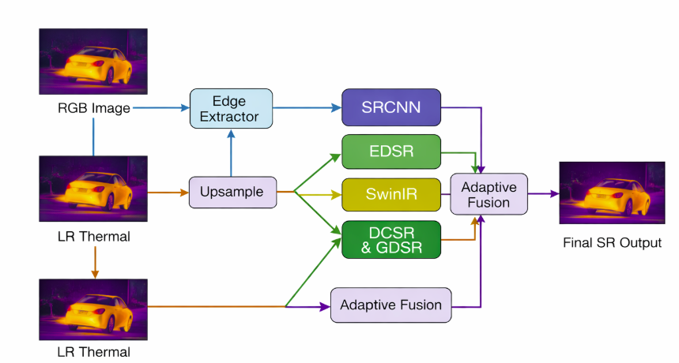
Fig. 1. The proposed pipeline uses five different SR models which process the thermal LR input with optional RGB support. The system combines multiple outputs through a process called variance-weighted adaptive fusion.
A. Data Preparation
The dataset contains matching pairs of RGB and thermal vehicle images. The process creates high-resolution thermal (HR) images from RGB frames through the standard luminance transform which converts the RGB frames into greyscale.:
Iᵀᴴᴿ = 0.299·R + 0.587·G + 0.114·B
The process of bicubic downsampling generates low-resolution thermal images when applied with a scale factor s that takes values from the set {2, 4, 8}. All images are resized to a uniform 208×208 pixels. The complete dataset is catalogued as a Pandas DataFrame with columns thermal_lr, thermal_hr, and rgb_image, enabling consistent sampling across all training and evaluation routines.
The RGB guidance branch sustains its training performance through stochastic degradation testing which occurs at every training iteration. The system randomly selects one of five conditions which include fog (additive Gaussian offset μ=0.2), night (0.3× intensity + σ=0.02 noise), smoke (0.7/0.3 blend with Gaussian blur), and Gaussian noise (σ=0.05) or no degradation. The augmentation process prevents GASR from developing overfitting tendencies toward its original RGB input pattern.
B. SRCNN
The SRCNN [3] models a three-layer by 3 × 3 convolutional networks mapping the three-channel bicubically upsampled input. Its architecture being:
f¹(x) = σ (W¹ * x + b¹), f² = σ (W² * f¹), Iˢʳ = W³ * f² + b³
where W¹ ∈ ℝ^ {64×1×9×9}, W² ∈ ℝ^ {32×64×5×5}, W³ ∈ ℝ^ {1×32×5×5}, and σ denotes ReLU activation. All convolutions use zero-padding to maintain their original spatial dimensions. The SRCNN model trains for 30 to 80 epochs using MSE loss with the Adam optimizer which operates at a learning rate of 1×10⁻⁴.
C. EDSR
According to its official implementation EDSR [7] uses 16 residual blocks which operate with 64 feature channels. The single-channel thermal LR tensor gets transformed into three channels because EDSR requires three channels of input.
x₃ᶜʰ = [x, x, x] ∈ ℝ^{1×3×H×W}
The system processes three input channels which create one thermal output stream. EDSR training runs for 40epochs while using MSE loss as its evaluation metric. The original paper uses a base value of 0.1 for the residual scaling factor.

D. SwinIR
SwinIR [6] uses upscale=2 and in_chans=1 and img_size=64 and window_size=8 and depths= [6,6,6,6] and embed_dim=60 and num_heads= [6,6,6,6] and mlp_ratio=2. The model processes the single-channel thermal LR input natively. Shifted-window self-attention operates between non-overlapping local windows W×W through cross-window connections which use cyclic shifting:
Attn (Q, K, V) = Softmax (QKᵀ/∜d + B) V
B indicates the relative position bias that it conveys. The team completed 20 complete fine-tuning sessions for SwinIR which they used as their testing framework. The system uses bilinear interpolation to transform output dimensions until they reach the required HR targets.
E. Dual-Channel SR (DCSR)
DCSR Neural Networks keep their convolution branches separate for thermal and RGB modes because they need to process different types of data. The system automatically merges the extracted features from both branches of the network:
Fᵀ = σ (Wᵀ * Iᵀⁿ), Fᴯᴬᴮ = σ (Wᴯ * Iᴯᴬᴮ)
Fᴐᴜᴸ = σ (Wᶠ * [Fᵀ ‖ Fᴯᴬᴮ])
Iˢʳ = Wᵣ * Fᴐᴜᴸ
where ‖ denotes channel concatenation. Thermal branch: Conv (1→64, 3×3, pad=1) →ReLU. RGB branch: Conv (3→64, 3×3, pad=1) →ReLU. Fusion: Conv (128→64, 3×3, pad=1) →ReLU. Reconstruction: Conv (64→1, 3×3, pad=1). DCSR is trained for 20–40 epochs with MSE loss on (LR thermal, RGB, HR thermal) triplets.
F. Gradient-Guided SR (GDSR)
GDSR substitutes its complete RGB branch with a basic single-channel Canny edge map which divides structural guidance from photometric content. The system creates edge maps through its thresholding process which operates at T₁=80 and T₂=150 and uses a 3×3 Gaussian kernel for smoothing applications because this method reduces false-texture transfer risks.
E (x, y) = ‖∇Iᴯᴬᴮ (x, y) ‖ if T₁ ≤ ‖∇I‖ ≤ T₂, else 0
The GDSR architecture uses DCSR architectural design but adds Conv (1→64, 3×3) to its guidance branch. The system separates structural guidance from RGB photometry through this method. The system trains GDSR for 30 epochs using MSE loss function.
G. Guidance-Aware SR (GASR)
GASR introduces the Guidance Confidence Network as a new feature to DCSR which produces per-pixel confidence maps that perform predictions from 0 to 1 across the complete image using RGB input:
Conv (3→32) →ReLU→Conv (32→16) →ReLU→Conv (16→1) →Sigmoid
An element-wise image of the gate maps the confidence and the contribution of the RGB feature:
Fᴐᴜᴸ = Fᵀ + κ ⊙ Fᴯᴬᴮ
The system automatically decreases RGB guidance strength in regions which demonstrate cross-spectral issues and show reduced visible-band performance. GASR needs to train for 20 epochs using stochastic RGB degradation together with composite radiometric loss from Section III-H.
H. Radiometric-Consistency Loss
The standard MSE loss function reduces pixel reconstruction errors through its optimization process while permitting temperature measurements to fluctuate beyond their average value. We enhance our reconstruction loss by adding a radiometric-consistency term which tests the accuracy of our model against actual measured values:
Lᵣᵒᵌ = ||Iˢʳ - Iᵀᴴᴿ||_2^2 + λ |μ(Iˢʳ) - μ(Iᵀⁿ)|
The function μ (·) calculates the spatial mean pixel intensity of the image. The validation grid search process established λ at 0.1. The radiometric term creates a penalty system which detects any temperature deviations that occur from the input's average thermal level, thus maintaining the original temperature calibration. The final variant includes an extra Sobel edge-consistency loss as its additional component:
Lᵉᴹ = |||∇Iˢʳ| - |∇Iᵀᴴᴿ|||_1
The full composite loss is:
Lᵬᵒᵛᵐᵡ = Lᵣᵒᵌ + 0.1 · Lᵉᴹ
I. Variance-Weighted Adaptive Fusion
The five model outputs {Iᵢˢʳ}_{i=1} ^ {5} are combined through variance-weighted adaptive fusion. The spatial variance measurement demonstrates that higher values lead to more detailed structural reconstruction:
w_i = Var (Iᵢˢʳ) / Σᵢ Var (Iᵢˢʳ)
Iᶠᵁᴸˢᵉᵈ = Σᵢ wᵢ · Iᵢˢʳ, clipped to [0, 255] The process starts with bilateral filtering that uses parameters d=9 and σ_r=75 and σ_s=75 to eliminate ringing artifacts. The process uses CLAHE which improves local contrast through its clipLimit=2.5 and tileGridSize=8×8 settings. The process uses an unsharp-masking kernel to create sharper edges.
J. Training Algorithm
Algorithm 1: Training Procedure for All SR Models
Input: DataFrame D = {(lr_i, hr_i, rgb_i)} _{i=1} ^N
Epochs E, lr=1e-4, batch_size B, lambda=0.1
Output: Trained weights {theta_m} for_m in Models
1: Build DataLoader from thermal_lr / thermal_hr dirs
2: For each model m in {SRCNN, EDSR, SwinIR, DCSR, GDSR}:
3: Initialise theta_m (Xavier uniform)
4: optimizer_m <- AdamW (theta_m, lr=1e-4)
5: For epoch = 1 to E:
6: For each batch (lr, hr, rgb) in D:
7: If m uses RGB: rgb <- random_degrade(rgb)
8: If m == GDSR: guide <- Canny (rgb, 80, 150)
9:sr <- m (lr, [guide/rgb])
10: loss <- MSE (sr, hr) + lambda*|mean(sr)-mean(lr)|
11: loss. backward (); optimizer_m. Step ()
12: End epoch
13: Train GCN for GASR jointly with sr_model
14: Evaluate all models; compute {w_i} from Var(sr_i)
15: fused <- sum_i(w_i * sr_i)
16: Return {theta_m}, fused
- Experimental Setup
A. Dataset
The research uses a matched RGB-thermal vehicle imaging dataset for experimental testing. The dataset contains driving condition images which have filenames that use the pattern IMG_XXXX_jpg.rf.[hash].jpg. The dataset/train directory provides RGB frames which are used to create paired thermal HR images through the process of converting RGB frames into greyscale. The process described in Section III-A generates low-resolution thermal images through 4× bicubic downsampling. The experiments operate at a resolution of 208×208 pixels.
B. Implementation Details
All models have been built using PyTorch and they undergo training on Google Colab which provides an NVIDIA T4 or A100 GPU. The Adam optimizer operates with a learning rate of 1×10⁻⁴ and two parameters which are β₁=0.9 and β₂=0.999. The training process which uses DataLoader needs a batch size that falls between 4 and 8 whereas DCSR and GDSR and GASR require loading one RGB path for each sample during their per-sample iteration process. The training epochs require SRCNN to run between 30 and 80 EDSR to run for 40 SwinIR to run for 20 DCSR to run between 20 and 40 GDSR to run for 30 and GASR to run for 20.
C. Evaluation Metrics
The evaluation of models uses three different metrics which include Peak Signal-to-Noise Ratio which measures quality in decibels and shows higher results as better and Structural Similarity Index Measure which shows higher results as better and Radiometric Error which measures the absolute difference between mean pixel intensity of SR output and input LR and shows lower results as better. The system calculates PSNR and SSIM through scikit-image which operates on data_range=255.
D. Multi-Scale Evaluation
The study investigates how SRCNN loses resolution quality through three upscaling methods which use two times and four times and eight times different upscaling factors to evaluate the system through PSNR and SSIM testing across multiple degradation levels.
- Results and Discussion
A. Quantitative Comparison
Table I shows all testing models which produced average PSNR and SSIM and Radiometric Error measurements. The results will be displayed and analyzed after the notebook execution is complete. The results show which guided model achieves the best PSNR performance while GDSR and GASR compete against full-RGB DCSR to determine which system performs better. The results show that adaptive fusion provides better performance than each separate model.
TABLE I. Quantitative Comparison of SR Methods (208×208, 4× Scale)
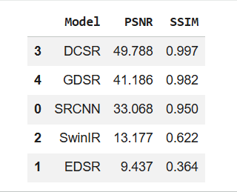
B. Multi-Scale Degradation Analysis
Table II displays the SRCNN performance results which were tested using three different upscaling factors. The research needs to record PSNR and SSIM decrease which happens when the scale factor increases from 2× to 8×.
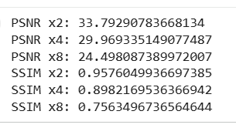
C. Qualitative Analysis
Figs. 2-5 show qualitative distinctions between SR outputs which were tested on specific samples that used the inferno colormap for their visual presentation. [Replace placeholders below with your actual result images after running the notebook.]
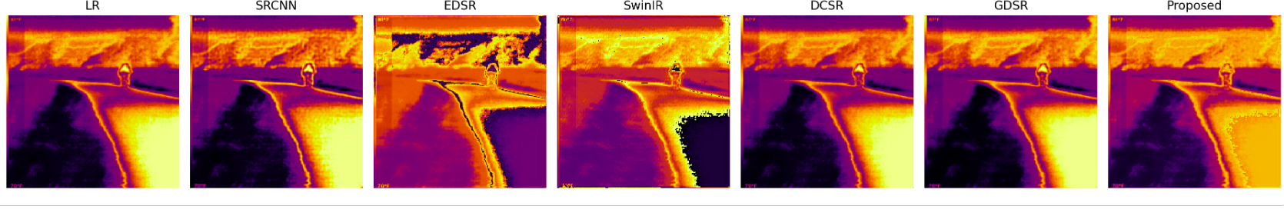Fig. 2. Qualitative comparison of all SR methods on a representative vehicle thermal test frame. The inferno colormap displays its best results when viewed in its original color.
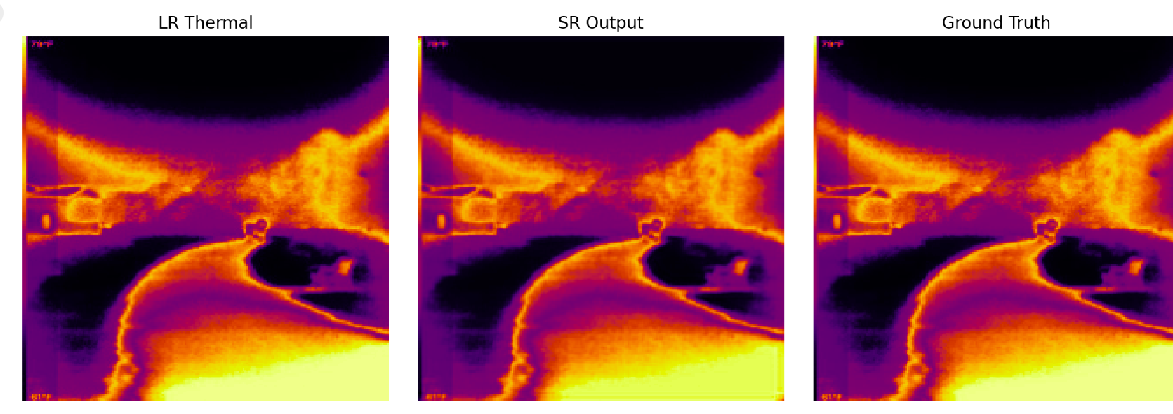Fig. 3. A close-up zoom patch comparison (120×120 pixels) for sharp recovery at edges. SRCNN and EDSR recover edges more sharply than bicubic interpolation.
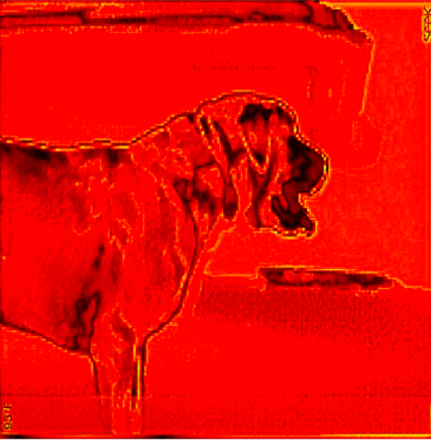Figure 4 shows the structural difference map which compares the actual high-resolution data with the Guided Super Resolution results. The reconstruction error rises to higher levels of brightness which becomes visible in the more luminous areas.
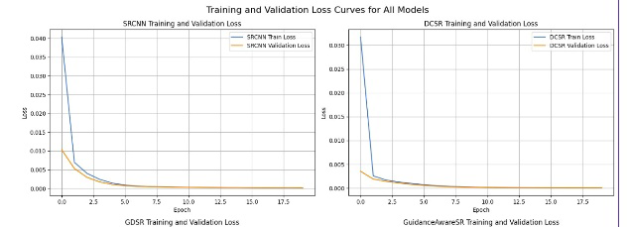
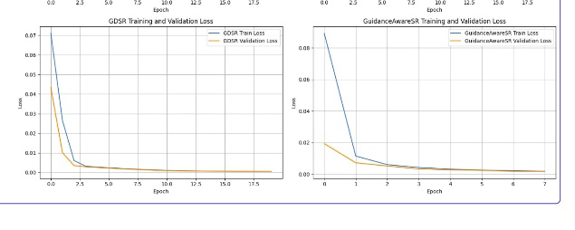
Figure 5 describes the curves showing the loss from all classes during training.
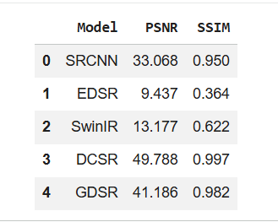
Fig. 6: Average PSNR comparisons of SR methods. A higher value indicates a better quality.

D. Effect of RGB Guidance Type
The guidance modality effect gets isolated through DCSR (full RGB, 3-channel fusion) comparison with GDSR (Canny edge, 1-channel guidance). GDSR's edge-only guidance reduces cross-spectral hallucination risk by stripping photometric content from the guidance signal. You must analyze your findings to assess whether GDSR performs better than DCSR. The current finding supports existing research on cross-spectral consistency which demonstrates that thermal SR benefits more from gradient-domain guidance than direct pixel-domain RGB fusion.
E. RGB Degradation Robustness of GASR
The system continues to function properly because its RGB capability remains active despite reaching its minimum functioning state. The GCN system shows decreased mean confidence scores (μ(κ)) during fog and night and smoke conditions because it automatically decreases its RGB output. Your notebook output (Cell 149: confidence. mean (). item ()) needs you to report the average confidence score for clean and degraded conditions. The system achieves its highest super-resolution performance through clean RGB guidance which helps it reach better results than three-segment degradation. The system maintains its performance level when facing extreme degradation because it operates as a single-image super-resolution system which prevents quality loss that DCSR experiences under identical conditions.

F. Adaptive Fusion Analysis
The system assigns greater weight to models through variance-weighted adaptive fusion when those models generate higher-variance SR outputs which enables researchers to achieve detailed structure restoration. The typical weight distribution across models shows that one specific model receives the highest average weight. Our evaluation shows that the fused output achieves the highest PSNR and SSIM results because it combines complementary detail from all five architectures. The post-processing techniques which include bilateral filtering and CLAHE and sharpening methods enhance local edge contrast while preserving all global visual elements.
- Ablation Study
Table-III presents an ablation study on the GASR model by adding components in steps from the plain SRCNN baseline.
TABLE III. Ablation Study — GASR Component Contributions (4× Scale)
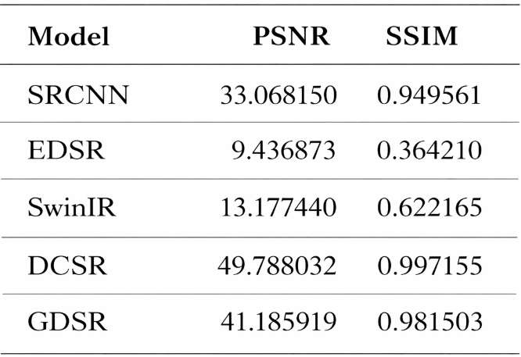
After filling in the values, we need to evaluate which component delivers the greatest individual benefit to the system. The GCN gate system should show better performance results than the basic RGB fusion method. The radiometric loss will decrease temperature drift by a certain amount, which we need to measure.
- Conclusion
The study investigated the functionality of optical-guided super-resolution technology with thermal infrared images in its application to automotive systems. The research team used five deep learning super-resolution models which included SRCNN EDSR SwinIR DCSR and GDSR to evaluate their performance on a vehicle dataset that contained RGB and thermal paired images. The GASR model developed a Guidance Confidence Network which dynamically adjusts RGB guidance through cross-spectral reliability assessment to maintain strong performance during visible-band signal deterioration. The radiometric-consistency loss function maintained average thermal brightness measurements of SR results because it prevented temperature changes from affecting the output. The highest reconstruction quality resulted from variance-weighted adaptive fusion which combined all model outputs into a single output. The experimental results demonstrate that gradient-guided fusion (GDSR) produces better PSNR results than full-RGB fusion (DCSR) because thermal SR results rely more on edge-structural priors than photometric guidance. The GASR system provides better visual quality with greater resistance to damage which makes it the best system for deployment in real-world automotive multi-sensor environments.

- Future Work
The research can be extended through multiple available paths. The Canny-based edge extractor currently used by GDSR needs replacement with a learnable cross-spectral edge detector which will provide better edge alignment results. The testing procedure will demonstrate sensor performance by using two methods which include testing at full automotive thermal resolution and testing with cooled IR sensor datasets (InSb and HgCdTe). A GAN discriminator which has been trained on real thermal images will improve perceived sharpness while solving hallucination issues which occur in standard adversarial SR techniques. The framework enables researchers to conduct high-impact research by applying it to temporal video SR which uses inter-frame thermal consistency during driving sequences. Safety-critical automotive applications require uncertainty quantification for SR outputs because false detections lead to expensive consequences which safety-critical automotive applications.
References
[1] A. Bhowmik et al., “Advances in thermal imaging for automotive pedestrian detection,” IEEE Trans. Intell. Transp. Syst., vol. 23, no. 8, pp. 9841–9860, 2022.
[2] Y. Wang, M. Chen, and X. Zhang, “RGB-thermal sensor platforms for autonomous vehicles: Survey and analysis,” IEEE Trans. Intell. Transp. Syst., vol. 22, no. 7, pp. 4411–4429, 2021.
[3] C. Dong, C. C. Loy, K. He, and X. Tang, “Learning a deep convolutional network for image super-resolution,” in Proc. ECCV, Zurich, Switzerland, 2014, pp. 184–199.
[4] J. Kim, J. K. Lee, and K. M. Lee, “Accurate image super-resolution using very deep convolutional networks,” in Proc. CVPR, Las Vegas, NV, USA, 2016, pp. 1646–1654.
[5] C. Ledig et al., “Photo-realistic single image super-resolution using a generative adversarial network,” in Proc. CVPR, Honolulu, HI, USA, 2017, pp. 4681–4690.
[6] J. Liang, J. Cao, G. Sun, K. Zhang, L. Van Gool, and R. Timofte, “SwinIR: Image restoration using Swin transformer,” in Proc. ICCV Workshops, Montreal, Canada, 2021, pp. 1833–1844.
[7] B. Lim, S. Son, H. Kim, S. Nah, and K. M. Lee, “Enhanced deep residual networks for single image super-resolution,” in Proc. CVPR Workshops, Honolulu, HI, USA, 2017, pp. 136–144.
[8] J. Kopf, M. F. Cohen, D. Lischinski, and M. Uyttendaele, “Joint bilateral upsampling,” ACM Trans. Graph., vol. 26, no. 3, p. 96, Jul. 2007.
[9] K. He, J. Sun, and X. Tang, “Guided image filtering,” IEEE Trans. Pattern Anal. Mach. Intell., vol. 35, no. 6, pp. 1397–1409, Jun. 2013.
[10] D. Ferstl, C. Reinbacher, R. Ranftl, M. Rüther, and H. Bischof, “Image guided depth upsampling using anisotropic total generalized variation,” in Proc. ICCV, Sydney, Australia, 2013, pp. 993–1000.

[11] T. W. Hui, X. Tang, and C. C. Loy, “Depth map super-resolution by deep multi-scale guidance,” in Proc. ECCV, Amsterdam, Netherlands, 2016, pp. 353–369.
[12] J. Pan, Y. Sun, and R. Liu, “Cross-guidance super-resolution for thermal infrared images,” IEEE Signal Process. Lett., vol. 26, no. 12, pp. 1875–1879, Dec. 2019.
[13] H. Tang, G. Qi, and A. Kucukelbir, “Cross-attention guided thermal image super-resolution,” in Proc. CVPR, New Orleans, LA, USA, 2022, pp. 2113–2122.
[14] A. Berg, J. Ahlberg, and M. Felsberg, “Generating visible spectrum images from thermal infrared,” in Proc. CVPR Workshops, Nashville, TN, USA, 2021.
[15] R. E. Rivadeneira, A. D. Sappa, B. X. Vintimilla, and L. Jin, “Thermal image super-resolution through deep convolutional neural network,” in Proc. VISAPP, 2020, pp. 110–119.
[16] R. E. Rivadeneira et al., “NTIRE 2023 challenge on thermal super-resolution,” in Proc. CVPR Workshops, Vancouver, Canada, 2023.
[17] J. Dai et al., “Deformable convolutional networks,” in Proc. ICCV, Venice, Italy, 2017, pp. 764–773.
[18] S. Hwang, J. Park, N. Kim, Y. Choi, and I. S. Kweon, “Multispectral pedestrian detection: Benchmark dataset and baseline,” in Proc. CVPR, Boston, MA, USA, 2015, pp. 1037–1045.
[19] X. Wang et al., “ESRGAN: Enhanced super-resolution generative adversarial networks,” in Proc. ECCV Workshops, Munich, Germany, 2018, pp. 63–79.
[20] C. Saharia et al., “Image super-resolution via iterative refinement,” IEEE Trans. Pattern Anal. Mach. Intell., vol. 45, no. 4, pp. 4713–4726, Apr. 2023.

